**PASSIVE VOICE of MODAL VERBS**

**A.** Rewrite the sentences in passive voice.

1. I can answer the question. - 
2. She would carry the box. - 
3. You should open the window. - 
4. We might play cards. - 
5. You ought to wash the car. - 
6. He must fill in the form. - 
7. They need not buy bread. - 
8. He could not read the sentence. - 
9. Will the teacher test our English? - 
10. Could Jenny lock the door? - 

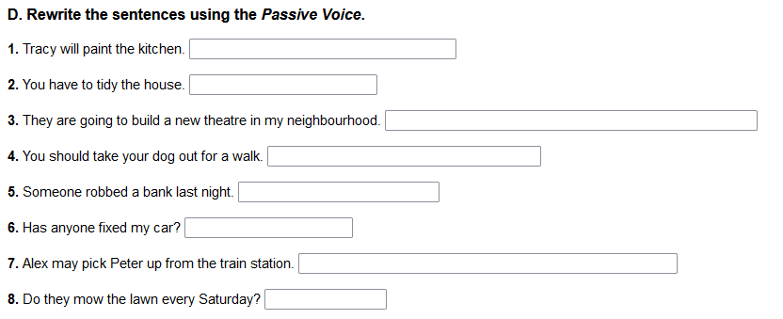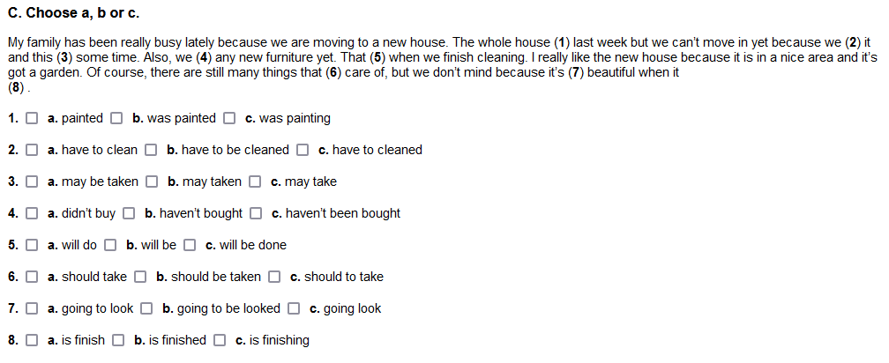

**PASSIVE VOICE of MODAL VERBS**

**A.** Rewrite the sentences in passive voice.

1. I can answer the question. - 
2. She would carry the box. - 
3. You should open the window. - 
4. We might play cards. - 
5. You ought to wash the car. - 
6. He must fill in the form. - 
7. They need not buy bread. - 
8. He could not read the sentence. - 
9. Will the teacher test our English? - 
10. Could Jenny lock the door? - 

